1. The user will input a string and we need to find the count of each character of the string and display it on console. We won’t be counting space character.

**Answer:**

|  |
| --- |
| internal static void Countcharacter(string str) {  var result=str.Replce(“ “,””);  Int number=result.Length;  Console.WriteLine(number);  } |

1. Given the following code, what is the output?

using System;

using System.Collections.Generic;

using System.Linq;

using System.Text;

namespace main1

{

class Program

{

static void Main(string[] args)

{

try

{

Console.WriteLine("Hello");

}

catch (ArgumentNullException)

{

Console.WriteLine("A");

}

catch (Exception)

{

Console.WriteLine("B");

}

finally

{

Console.WriteLine("C");

}

Console.ReadKey();

}

}

}

**Answer:**

|  |
| --- |
| Out put is c,  Whether there is a exception or not finally block will be executed; |

1. Consider the following HTML form.

<html>

<head><title>My Form</title></head>

<body>

<form name=*”myform”* method=*”post”* action=*””*>

My Field: <input type=*”text”* name=*”myfield”*>

</form>

</body>

</html>

1. Write code that retrieves the value of myfield when the form is submitted.

**Answer:**

|  |
| --- |
| Using Jquery  var myFieldvalue=$(“input[name=myField]”).val();  Console.log(myFieldvalue); |

b) Write code that stores this retrieved value so that it would only be available to this user

for the duration of the user’s session. You can assume the existence of any variables

required to perform this task.

**Answer:**

|  |
| --- |
| In frond end side we can store it in localstorage;  Ex:  var myFieldvalue=$(“input[name=myField]”).val();  localstorage.setItem(“myField”,myFieldvalue);  To access that value: var val=localstorage.setItem(“myField”):  In Back end side  We can store that value in session  Ex:Session[“myField”]=that value  Access var val=Session[“myField”].toString() |

1. Given a sorted array and a number x, write a function that counts the occurrences of x in the array with a runtime of at most O(log(n)) where n is the number of elements in the array.

Examples

Input: $myArray = **array**(1, 1, 2, 2, 2, 2, 3), x = 2

Output: 4 // x (or 2) occurs 4 times in arr[]

Input: $myArray = **array**(1, 1, 2, 2, 2, 2, 3), x = 3

Output: 1

Input: $myArray = **array**(1, 1, 2, 2, 2, 2, 3), x = 1

Output: 2

Input: $myArray = **array**(1, 1, 2, 2, 2, 2, 3), x = 4

Output: -1 // 4 doesn't occur in arr[]

**Answer:**

|  |
| --- |
| int []array={1,1,2,2,2,2,3};  int x=2;  int n=array.Length;  int result=0;  for(int i=0;i<n;I++){  if(x==array[i])  {  result ++  }  return result;  } |

1. One of the mobile service provider company in Sri Lanka wants to expose a service, which will provide a mobile recharge facility for end users. The flow is the user sends SMS in predefined format and application should parse the message and do the recharge accordingly. Now, the biggest challenge is the application gets a huge number of recharge requests during the peak hours and is not able to process each request, so the company is looking for something like where all the requests are parked when they come and process one by one.

As developer in this mobile company, you suggested a solution where it uses a cloud messaging service. please provide details on how you implement this with a sample console applications. You may have two console applications one as the client and the other as the server.

|  |
| --- |
| As I think .This is can be done using thread |

**Answer:**

## 5. Audi is a German based automaker who has been in business for than 100 years and is a leading manufacturer of luxury cars and SUVs. The company’s previous business model - Route 15 - was focused on 1.5 million in global sales. Audi is currently working towards their future strategy- 20/20 - and the company is in the process of developing an efficient system to track its global inventory. Audi’s warehouse is in Ingolstadt, Germany.

ER diagram:

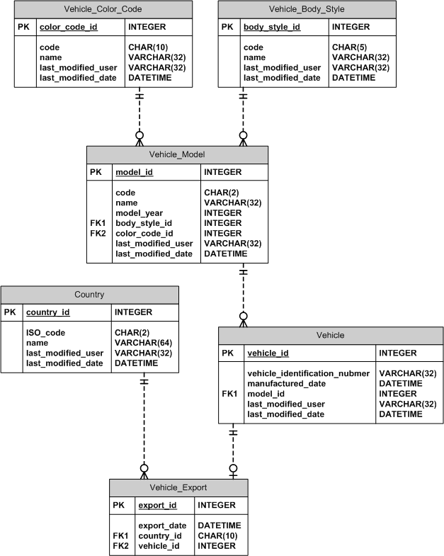

a) Write a SQL query to retrieve the number of vehicles that were exported out of Audi’s warehouse in Ingolstadt in 2011.

**Answer:**

|  |
| --- |
| Select count(vehicle_id) as Vehicle count in 2011)  from vehicle_Export  Where year(export_date)=2011 |

b) Find the number of 2011 model SUVs exported to Sri Lanka (code is ‘SL’) in 2011 which were manufactured from June 15th, 2010 to December 24th, 2010. The code for body style SUV is ‘suv’.

**Answer:**

|  |
| --- |
| select count(vbs.code) as ToalNoOFSUVModel  from  Vehicle_Export ve  inner join Country c  ve.country_id= c.country_Id  inner join Vehicle v  on v.vehicle_Id=ve.vehicle_id  inner join Vehicle_Model vm  on vm.model_Id=v.model_id  inner join Vehicle_Body_Style vbs  on vbs.body_style_Id=vm.body_style_id  where c.ISO_code="SL" and vbs.code="suv’"  and ve.export_date between '2010-06-15' and '2010-12-24' |

1. Which of the figures can be used to continue the series given below?



a)b)  c)  d)  e) 

**Answer:**

|  |
| --- |
| Answer is d |

1. At a conference, 12 members shook hands with each other before & after the meeting. How many total number of handshakes occurred?

a) 100 b) 132 c) 145 d) 144 e) 121

**Answer:**

|  |
| --- |
| Answer is 132 |

1. Design a class hierarchy to model these 4 animals: **Frog**, **Dog**, **Owl** and **Duck**. Add the following operations: Eat, Move (as in travelling), and Speak. In your design, make assumptions that some animals may perform an operation the same way or differently from one another. You can draw a diagram or write some simple code to represent the hierarchy.

**Answer:**

**See below for answer**

|  |
| --- |
| Public class Animal{  Public int Id {get; set;}  Public string Name {get; set;}  Public void Eat(){  }  Public void Speak(){  }  }  Public void Move(){  }  }  Public class Dog:Animal  {    }  Public class Frog:Animal  {  Public void Jump(){  }  }  Public class Owl:Animal  {  Public void Flying(){  }  }  Public class Duck:Animal  {  Public void Swimming(){  }  } |